**Weekly Development Log Week 1 – Ben Larrison**

**First, I wanted to make sure I completed all the tasks for phase 1.**

Phase 1

4/29 - 5/5: Familiarization with StarCraft II API and setting up the development environment

* Identifying how navmeshes are used in SCII
* Identifying how units move on SCII maps
  + Swarm AI
  + How can we influence this navigation using an influence map
* SCII Development Environment Setup

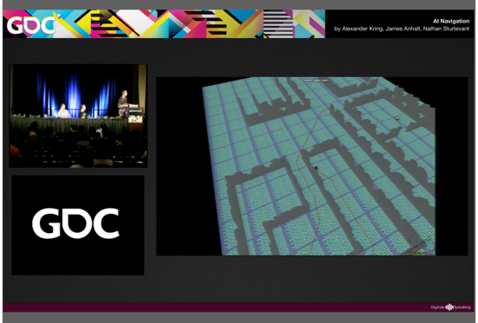**I needed to identify how navmeshes are used in SCII**

* <http://gameai.com/papers.php?a=23&t=&e=&y>= This presentation at GDC goes over the StarCraft II navmesh and the AI path planning, but I wanted to investigate for myself.
* I opened up the map editor to get a feel for how the navmesh works. The map editor was somewhat helpful to get an understanding of how the map works, but it ran very slowly.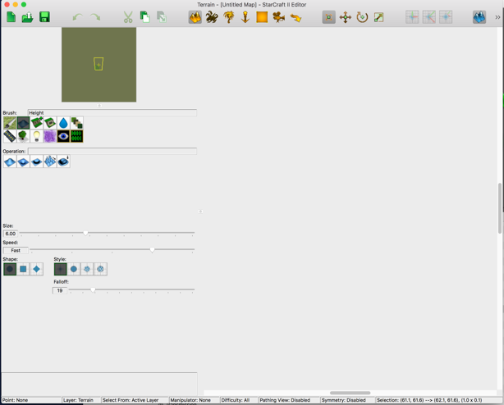
* After doing these things I have an understanding of SCII’s navmesh, and how units move on the map.

**Next, I needed to think about how we could influence the movement with the addition of an influence map.**

* I read this article on influence maps in video games: <http://aigamedev.com/open/tutorial/influence-map-mechanics/>
* I found this sentence interesting:



* So we should use the influence map to label these features and allow our AI bot to use the information

**Next I needed to set up the environment SCII Development Environment**

* I used VirtualBox to install Ubuntu on my computer. I set up PySC2 and got familiar with the environment. I ran a couple example bots.

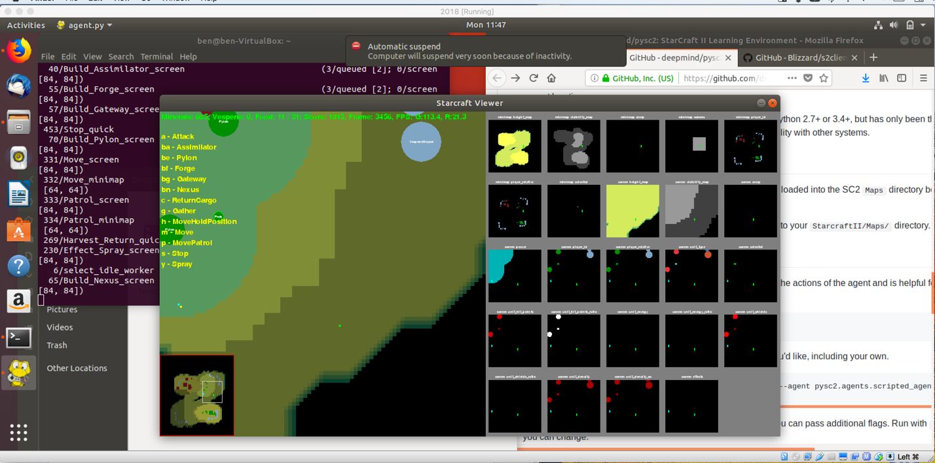

**Finally, I wanted to get a better understanding of SCII from a player’s perspective.**

* I read the starcraft II beginner’s guide: <https://starcraft2.com/en-us/game>
* I read through the Starcraft II Reddit: <https://www.reddit.com/r/starcraft/>
* I started playing through the campaign.